2019 - 2021

strategic PLan

21 Carmichael Street #206
Essex Junction, VT 05452
802.871.5002
www.vsavt.org
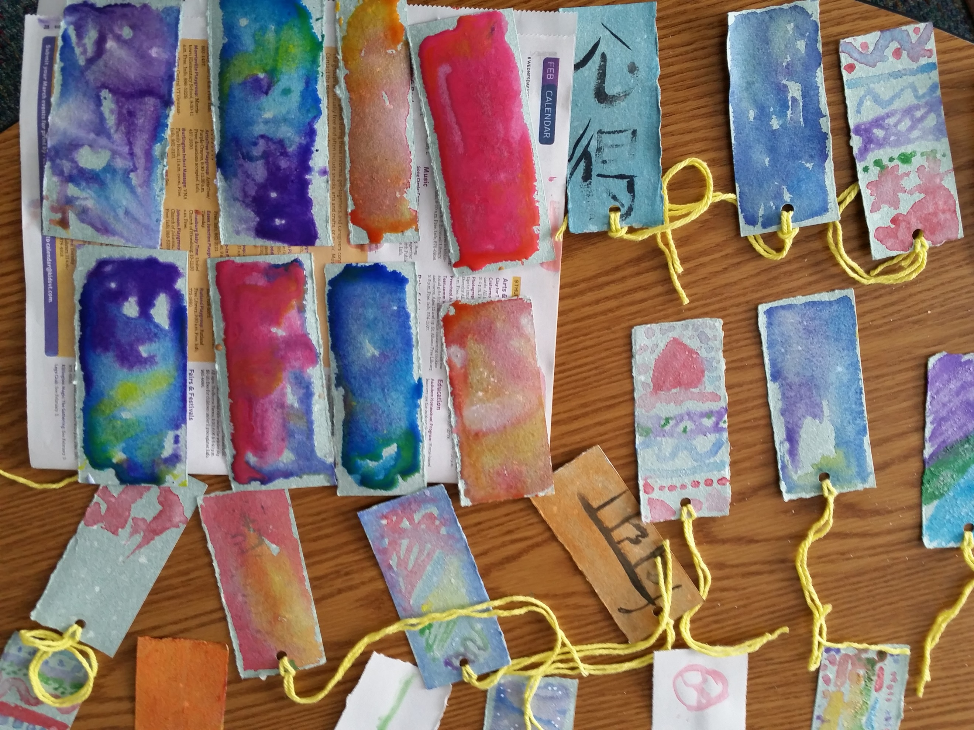

VSA Vermont 2019-2021 Strategic Plan

INTRODUCTION

The following strategic plan was developed from September – December 2018 by the staff and board of directors of VSA Vermont under the guidance of facilitator Claire Wheeler. The overarching goal of this plan is that by the end of 2021 VSA Vermont will be the premier statewide organization focused on the arts and inclusion.

As an organization, we believe that all Vermonters deserve access to the arts and, through our work, Vermont will become a more inclusive community for people with disabilities. We will change systems to be more accessible and provide opportunities for people with disabilities to engage their creativity. VSA Vermont will work with a broad partnership of students, educators, arts organizations, and individuals with disabilities to achieve this important mission. The organization will continue to embrace a culture of accessibility, leading the state as an example of accessibility and inclusion best practices in its programs and in the workplace.

The arts can be both a mirror and a window into the human experience and through increasing access to the arts, we will build a stronger future for all Vermonters.

The contents of this plan are a working version until voted on an approved by both the staff and board.

Approved Date: ______________________________________

____________________________________ ____________________________________
Katie Miller Ashley McCullough
Executive Director President, Board of Directors

PREVIOUS STRATEGIC PLAN REVIEW

During the strategic planning process, VSA Vermont staff and board reviewed the previous plan, and identified areas of success and those that were opportunities for continued growth.

The following were highlights of note from the conversation:
- Addressed staff salaries & benefits but could use revisiting
- A full-time development staff position was added and filled
- Board members were added, however there are still vacant seats
- Results Based Accountability was implemented, and there is room to continue to strengthen our skills as a team and use the framework to our advantage
- Increased the visibility of VSA Vermont through methods like signage, teachers wearing badges, and social media. The group recognized that we need to do more to build awareness, but not until we rename.
- Created and maintained a contingency fund equal to six months of expenses
- Relocating offices to an accessible location was a success
- Leveraging volunteers and interns was successful
- A positive work environment was established
- Areas for continued growth included:
  - Expanding the major donor program
  - Establishing a signature fundraiser event
  - Assessing and addressing staff capacity
  - Activate board committee structure

SWOT ANALYSIS

During the planning process, staff and board worked together to identify cross-cutting or overarching themes and takeaways to understand VSA Vermont’s current strategic position based on internal factors (strengths & weaknesses) and external forces (opportunities & threats).

STRENGTHS: Internal  - Need to rebrand shows up as a weakness (not being  - known) and an opportunity (chance to fix that)  - Passionate and flexible staff  - How to hold inclusive space  - Dedicated development staff  - Flexibility  - Dedication to the mission  - Varied skills among management team = well rounded staff group | WEAKNESSES: Internal areas for growth  - Unclear messaging, no one knows what “VSA” means  - On the edge between cohesion and chaos, cohesion is key to continued sustainability  - Lacking public awareness of the organization and its mission  - Tendency to take on projects and programs that don’t directly relate to the mission. Need to focus on what we do well and leave the other work to other organizations.  - We are not truly operating statewide due to not having many public programs. Difficult to do due to privacy and protecting our customers.  - Turnover in the Executive Director position  - Board needs an increased role in fundraising to address some threats and weaknesses
OPPORTUNITIES: External  - Social/emotional learning being a hot topic suggests that the rest of the world is catching up to our way. Suggests opportunity to do more for older adults.  - Leveraging partnerships with other organizations  - There is an increased focus on inclusion and access  - Funding threats could force us to hone our “niche” and focus on target customer. | THREATS: External  - To fundraise, we need credibility with the public.  - It’s hard to deliver a cohesive message because of  - all the different things we do.  - Funding cut threats at the state and federal level  - Losing the “VSA” name could harm credibility with other organizations and funders

WHO IS VSA VERMONT?

The Hedgehog Concept is based on an ancient Greek parable that states, "The fox knows many things, but the hedgehog knows one big thing." In the parable, the fox uses many strategies to try to catch the hedgehog. It sneaks, pounces, races, and plays dead. And yet, every time, it walks away defeated, its tender nose pricked by spines. The fox never learns that the hedgehog knows how to do one big thing perfectly: defend itself.

What is the “one big thing” we know and do?
What are we deeply passionate about?
- A belief in belonging
- Accessibility & inclusion
- Joy, fun, compassion, and creativity
- The power of art

Inclusion of and access for people with disabilities in the arts is our wheelhouse.

We make it happen through modeling, training, and celebration.

We can we be
the best at?

Modeling and training inclusion in the arts
What drives our resource engine?

Programs for people with disabilities and early childhood education grants

Theory Of Change

The Theory of Change exercise asks the following questions to pinpoint what drives the work of an organization:

What is the overarching philosophy that connects strategies?

How do these strategies add up to be more than the sum of the parts?

What is the connection between these strategies?

What do these strategies tell you about what beliefs or underlying mental models this team holds?

VSA Vermont’s Theory of Change:

Vermonters with and without disabilities deserve access to the arts.

Who it’s for: | Students & Teachers | Community Organizations | People with Disabilities
Where it happens: | Classroom Settings | Other Organizations | In the Community
The results we work to achieve: | - Creative engagement  - Empowerment  - Inclusion of diverse abilities  - Community building  - Arts Integration using the Universal Design for Learning framework | - Statewide culture of inclusion  - Valuing of access and inclusion | - Creative engagement  - Community Building  - Inclusion of and equity for people with disabilities  - Activating self-advocacy through creativity
The current programs that meet the need: | - Start With The Arts  - Arts to Smarts  - High School Performing Arts  - Teacher Workshops | - Workshops  - Consulting  - Presenting  - Trainings and professional development | - Mentoring  - Adult Arts  - Public Events  - Supporting Artists  - Displaying Artwork  - Accessible Exhibitions & Performances

Mission, Vision, and Values

Based on the findings of the SWOT analysis, Hedgehog, and Theory of Change exercises, it became apparent that VSA Vermont’s mission, vision, and values statements needed updating. Below are working versions of these statements.

Our updated mission is to use the magic of the arts to create a more inclusive Vermont for people with disabilities. We do this through education, exhibition, and capacity building programs for teachers, students, artists, and organizations.

Through our work in the arts, Vermonters of all abilities will have equal opportunities to engage in their communities and express themselves. We envision a Vermont where any person with a disability can enter any arts organization or learning environment and fully participate to the extent that they desire.

We believe:
- The arts should be accessible to Vermonters of all ages and abilities.
- Communities are strengthened by the inclusion of every voice.
- In the celebration of strengths and imagination and see possibility.
- The creative process creates space for bravery, authenticity, connection, and joy.
- Creative expression is empowering: through art all things are possible.
- In unconditional positive regard and that all people are perfect and whole exactly as they are.
- The arts create opportunity for accomplishment, confidence, and community. Through the arts we see things in a new way, ask questions, and experience life from a new perspective.
- Everyone belongs in their community and it is a basic human need to belong. The arts engage and connect people with their communities and express unique perspectives.
- People with and without disabilities should have the opportunity to experience the magic of the arts together.

GOALS AND STRATEGIES

To move the work of VSA Vermont forward over the next three years, staff and board used the planning session results to identify the following strategic goals and accompanying strategies.

Strategies with an asterisk* and bolded in blue have been identified as immediate priorities 2019.

Board of Directors
GOAL: Increase the capacity of the board of directors to support sustainable organization growth.
- *Build capacity of board members through training (2019 - 2021)
  - Priority Topics: Rebranding, organization messaging, fundraising, nonprofit finance, mission-related topics, disability awareness
- Evaluate and improve governance structure (2019 - 2020)
  - *Assessment of current board engagement and state of development
  - *Priority Committees: Finance, Development (include staff members)
  - Identify committee purpose and workplan
  - Evaluate organizational policies
- Formalize board recruitment process (2020 – 2021)
  - Assess board needs and add board members based on needed expertise
  - Develop matrix with priority needs for board members
  - Update onboarding materials

Plan the Work, Work the Plan
- Annual day-long retreat for staff and board to share highlights, annual program plans, budget, and check in on strategic plan.
The Internal Workings: Staff, Management, and Administration
GOAL: Refine internal structures to stabilize organizational operations and maximize capacity. Create a supportive work environment that values staff expertise, meets organizational needs, and provides opportunities for staff growth and development.
- Regular review of staff salaries in relation to market rates and professional expertise (2019 – 2021)
- *Create formalized training and evaluation process for teaching artists (2019 - 2020)
  - Prioritize the intentional use of social justice and inclusion of diverse populations
- *Ensure appropriate workload capacity amongst staff (2019-2021)
  - *Develop a work-flow based organizational chart (2019)
  - *Conduct a capacity audit for staff in alignment with performance reviews that regularly inform staffing strategy (2019 – 2021)
- Update and revise personnel policy (2020 – 2021)
  - Priority areas: remote work, benefits, parental leave, annual leave

Plan the Work, Work the Plan
- Annual performance reviews: Update job descriptions and succession plans at annual performance reviews
- Annual capacity audit: Update work flow organizational chart and use it for annual capacity audit that will be used to inform the following year’s program plan and calendar
The Work: Programs
GOAL: Refine and update current programs with a focus on meeting the needs of educational settings, artists with disabilities, and Vermont’s arts organizations.
- *Evaluate sustainability (cost/impact/income ratio) of all programs
  - Develop RBA performance measures for each program and customer group (2019 – 2020)
  - Develop common templates for data collection
  - Assess the true cost of programs including dollars, staff time and energy, and partner buy-in
- *Conduct an annual program planning process to enable decision-making about program design and delivery in relation to mission impact.
  - Program data and impact review meeting as entire staff
  - Program planning staff retreat to adjust scale and types of programs offered
  - Create an annual program calendar that maps out offerings and responsible staff
- Develop assessment rubric for new partnerships and programs (2021)
- Review and integrate social justice standards into all program planning and implementation (2020 – 2021)
  - Explore the use of the Social Just Standards from Teaching Tolerance
  - Include training for all staff

Plan the Work, Work the Plan
- Annual program calendar
- Annual data and impact review meeting to use RBA as program decision-making tool
Spreading the Word: Marketing and Communications
GOAL: Create a brand that is clear, focused, and reflective of the mission and impact of VSA Vermont and positions the organization to be the premier organization on the arts and inclusion in Vermont.
- *Formally adopt new mission, vision, values statement (2019)
- *New Identity: Name, logo (2019)
- *Trainings for board, staff, and teaching artists (2019 – 2020)
- Create and use an ongoing communications plan to increase statewide visibility (2021)
- Develop impact statements for each program (2020)
Plan the Work, Work the Plan
- Annual communications plan to support goals and program plan

The Funds: Finance and Fundraising
GOAL: Formalize and standardize structures to create a sustainable financial base that enables sustainability.
- Develop a sustainable, growth- oriented fundraising strategy that:
  - Creates a major gifts program (2020 - 2021)
  - Explores feasibility of annual fundraising event (2020)
  - Increase unrestricted income, revenue generating, and fee for service programs (2021)
- Budget Process:
  - Move to multi-year budget structure (2021)
  - Train board on financial management to increase capacity of the fundraising committee (2020 - 2021)
Plan the Work, Work the Plan
- Annual fundraising plan
- Annual budget review

*Plan the Work, Work the Plan: Annual Strategies
- Quarterly review of strategic plan progress at staff and board meetings
- Staff and Board Retreat
- Performance Reviews
- Performance reviews & capacity audit
- Program Planning: Program data and impact review meetings, 1-1 program assessment, and program planning staff retreat
- Communications Plan
- Fundraising Plan
- Budget Review

SUPPORTING DOCUMENTS ATTACHED

  - Nonprofit Lifecycle Analysis
  - Planning Session Notes

