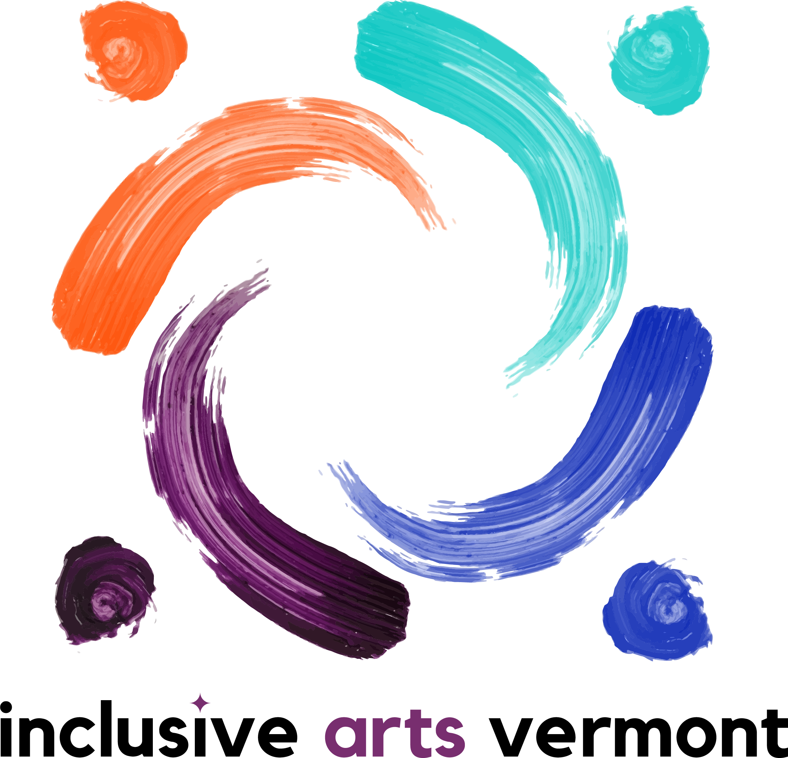

Inclusion Statement

We believe that all voices are valuable, and in accordance with our mission, we center our work on disability and access through the arts within the broader conversation of inclusion.

At Inclusive Arts Vermont we recognize the word "inclusion" has deep and nuanced meaning in today's society. As an organization, we believe in mutual growth and lifelong learning and therefore, we intentionally seek collaborations with organizations engaging diverse populations as we work to build inclusive communities throughout Vermont.

