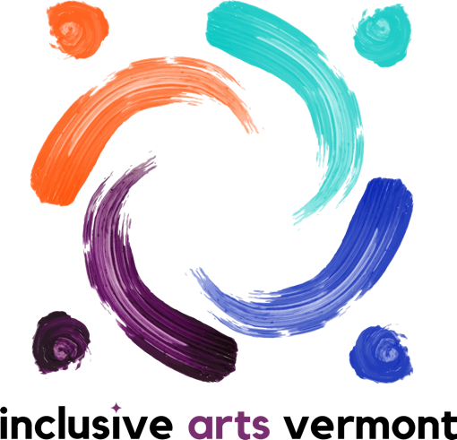

Arts and Advocacy Internship Application Questionnaire:

Application Deadline: February 24th

The Inclusive Arts Vermont internship is available to youth ages 15-21. The 7-week experience is youth-directed and open-ended. Students are expected to attend each session and work on their own. The internship offers credit hours as needed.
Interns will guide their own learning. Past internships have included making art, interviewing professionals, connecting with peers, and investigating topics of interest. The possibilities are endless!
Meeting times and dates: March 9th - April 31st 2021, Tuesdays 9:30am to 11am
For more information or to request an accommodation contact heidi@inclusiveartsvermont.org or call at 802-238-5170
*Please note we genuinely want to know about who you are and what interests you. People communicate in many ways: we are accepting applications in written format, artistic response, audio, video, live phone, or video call.

Name:

Age:

Grade in School (or Equivalent):

Email:

Phone:

Township:

Tell us about your interest and/or experience with:
The arts

Disability

Advocacy

What are you hoping to learn or gain from this internship?

What life experience, skills and strengths are you bringing?

What topics or issues are you most passionate about or want to learn more about?

What accommodations or supports might you need to be successful in this internship?

Anything else you would like us to know?

Please return applications to: heidi@inclusiveartsvermont.org By: February 24th

