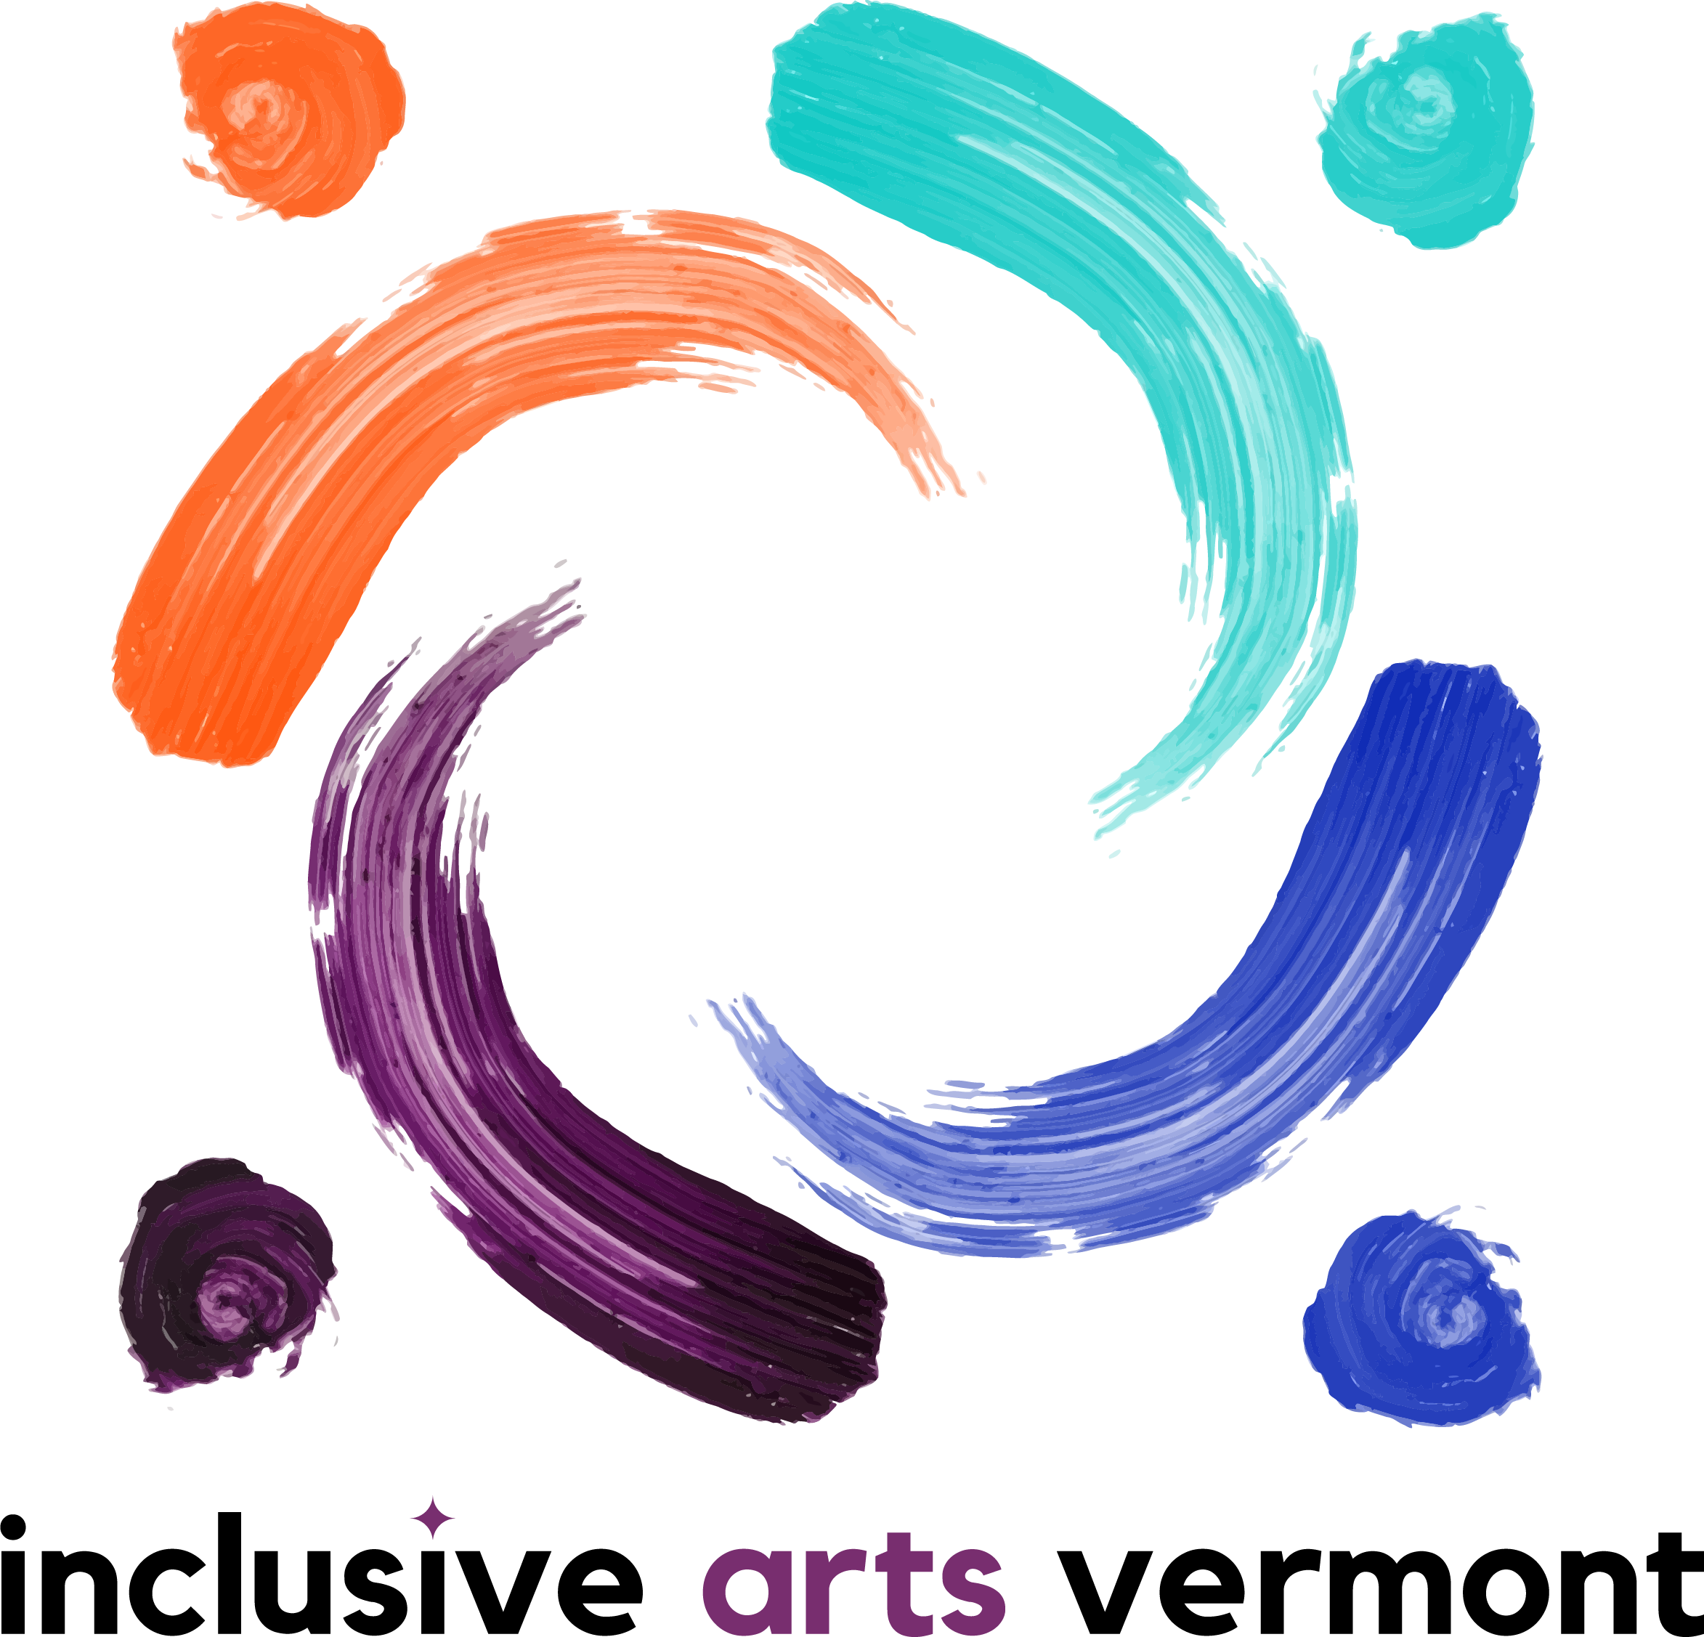
Internship Position: Arts and Advocacy 2021 Program Year
For more info contact heidi@inclusiveartsvermont.org or 802.238.5170
Inclusive Arts Vermont Mission Statement: Inclusive Arts Vermont uses the magic of the arts to engage the capabilities and enhance the confidence of children and adults with disabilities.
Dates: February -April 2021, meeting times and dates TBD
The Inclusive Arts Vermont internship is available to youth ages 15-21. The 8-week experience is youth-directed and open-ended. Students are expected to attend each session and work on their own. The internship offers credit hours as needed.
Interns will guide their own learning. Past internships have included making art, interviewing professionals, connecting with peers, and investigating topics of interest. The possibilities are endless!

Program Goals:
The Internship will provide:
- space for youth with disabilities to share their thoughts, resources and learning
- support for students to explore goals
- skill development

Intern Responsibilities:
Students will:
- attend all scheduled sessions
- communicate with advisors and peers
- develop goals for personal learning
- participate in reflection meetings with advisors
- complete documentation for school credit as needed
Inclusive Arts Vermont Advisor Responsibilities:
- provide guidance to students
- offer reflection and feedback
- match student interests with opportunities
- work with students to ensure accommodation needs are met
- assist with administrative documentation for school credit as needed

Advisors:
Riaz Clark, (he/she/they) Program Intern, Champlain College ‘21 - Social Work
Alexandra Turner, (she/her) Director of School and Community Programs
Heidi Swevens, (she/her) Director of Community Partnerships

To Apply:
Follow this Link for a Google Form:
Application Deadline: _____
** For Accommodations in the application (phone call, text in email, paper application in the mail, etc) contact heidi@inclusiveartsvermont.org or 802.238.5170
See our Website for more information!

www.inclusiveartsvermont.org

