Inclusive Arts Vermont
MASKED Exhibition
Artist Statements and Biographies

Aurora Berger
Artist Biography

Aurora Berger is a queer disabled artist working with photographic and alternative processes. Coming from an academic background, and currently working in education, Berger uses language and imagery to challenge ableist and heteronormative ideas. She creates works that investigate the concepts of normalcy, disability, agency, visual acuity, and interpretation. Berger holds an MFA from Claremont Graduate University, as well as a BFA and BA in Art Education from Prescott College. She is the recipient of the Kennedy Center VSA and Wynn Newhouse awards and is a current resident of the Art and Disability program through Art Beyond Sight and the 2021 Slant Projects artist programme. Berger has presented her work at several conferences including the 2020 College Art Association National Conference and her writing has been published by the National Institute for Learning Outcomes Assessment, Drkrm Editions, and in a forthcoming anthology from Brill | Sense.

Artist Statement
“I am a queer disabled artist working with photographic and alternative processes. I come from an academic background, and currently working in K-8 education. I use language and imagery to challenge ableist ideas and explore the parts of myself that I am just beginning to come to terms with. I am currently working on a manuscript exploring the intersections between disability and contemporary art.

Cumulatively my work creates an expansive self-portrait. Some images are literal self-portraits: photographs of my physical body, pictures of my life. Other images build on environmental cues that place the viewer in my position through fragmented imagery and visual confrontation. Through the use of various photographic and mixed mediums, the works investigate the concepts of normalcy, disability, medicalization, fragmentation, agency, visual acuity, and interpretation.”

Bob Gold
Artist Biography

“Throughout my life, whether I was teaching dentistry at Harvard University or being Captain in the Army, I have always found ways to be creative. I was a full-time dentist and a part time artist for 25 years, but after my traumatic brain injury in 1997, I devoted myself to art full time. Using digital manipulation and vivid colors, I developed my own style. I show mostly around the state of Vermont, and by interacting with people and showing them my work, I garner commissions and sell into private collections. In 2011, I won a scholarship for the Vermont Studio Center Artist Residency program and developed my technique of painting on canvas. In 2012, I was named Chaffee Art Center’s Artist of Distinction. I have been working with printer Jon Cone, the inventor of digital printing, since 2010 and we have collaborated on many pieces. Although I have been an artist for more than half a century, I still seek the input of others to help me grow and celebrate making mistakes in order to improve. In the past three years, my art has been exhibited at UVM Medical Center, Burlington International Airport, and the AVA Gallery in Lebanon, New Hampshire. In 2013, I was a featured guest lecturer at the Bennington Museum. I was also featured on the cover of the Journal of Rehabilitation, Research and Development in November 2015. In 2016, I was voted the winner of the People’s Choice Award at the South End Art Hop in Burlington. In 2018, I was chosen as one of the artists to participate in the “Artist to Watch 2018” exhibit at Vermont Arts Council’s Spotlight Gallery, curated by Ric Kasini Kadour, editor and publisher of Vermont Art Guide.”

Artist Statement
“In all my art, I strive to uncover the extraordinary hidden within the ordinary. I find it’s disturbingly easy to miss the beauty unfolding right in front of us. When my mobility became limited, I started to notice more and more beauty in my immediate surroundings. Focusing intently with my camera on appreciating the everyday in a new way helps me stay present. In my process, the composition of the photograph is more important than the color. I manipulate the colors in the computer and with acrylic paint. The vibrancy of the piece draws the viewer in and then the composition tells a story. The latest technology grants me the ability to experiment rapidly, and my current pieces have benefited immeasurably. Using delicate hand-detailing (with the aid of neurosurgeon’s operating glasses), and a sophisticated print process, I’m able to expose the inner richness that lies buried just below the surface of our daily lives.”

Burdena Hopps
Artist Biography
“Hello, my name is Burdena. I am 34 years old. I started doing ‘My Head’ as a school project at CCV for a Digital Art Communications certificate as a self-portrait. Instead of the typical drawing a picture of my face to show it, I decided to bring my creativity on show! The reason it is important for me to go to college is because I do have a developmental disability (low IQ). They told my mom I was unable to read, here I am I can read and succeed in college.

This is my first art show. I just decided to do it because it was ‘why not?’ It was a type of thing for me to jump on it. I have severe social anxiety, and I am trying to work on that. I am new being an artist and I am still crafting. I am learning to sew currently.”

Artist Statement
“This sculpture is made of foam, newspaper, water, and flour. It started with a process of three layers of paper. First layer waited for it to dry for two days, same thing for the second layer and third layer. After I did that, I got acrylic paper, which took a few days to let it dry. Add more to it because I wanted to make sure there is enough coating on it. Then a week later I put yarn in the head with some pearl pins. One by one. This took a few days to make sure it sticks. Then I put glitter on it to add some sparkle in it. I also added glue to keep the ‘hair’ yarn from falling.”

Callie Coffman
Artist Biography
Artist who makes hand-drawn, uplifting cards to share with loved ones.

“My name is Callie Coffman and I am an artist, business owner, and most recently a shirt designer. A lot has happened to everyone from 2019 to now and I am no exception. I took a class in late 2019 on making your small business dreams a reality and I decided to launch my business SweetGreets (greeting card company) to help people be happy through giving and getting craft greeting card that is uplifting, feeling loved, remembered, liked, and appreciated. I sold my product online and realized that people really liked and wanted my art, before this, I had doubts and small hopes for selling my art. Selling and displaying my art as well as stepping out of my comfort zone has paid off immensely, I am selling cards, doing commissions, designing cartoons for t-shirts and I am living my best ‘Artist’s’ life with confidence! An artist who makes hand-drawn uplifting cards that you can buy to share with loved ones. “

Artist Statement - “Me and My Dog”
“My artwork ‘Me and My Dog’ is a picture of a dog and its owner. The owner has long bangs that cover their eyes and the dog has long bangs that cover their eyes as well. My piece was meant to show that owners sometimes look like their dogs and that our pets are a reflection of us.”

Cristina Clarimón
Artist Biography

Madcollage is an artist from Madrid, Spain. She creates traditional, analog collages.

Her work has been exhibited internationally in galleries around the USA and in Europe. She has been selected to show in the Santa Fe Museum of Fine Arts and the Harwood Museum of Art in Taos (New Mexico), the Arts Center in St. Petersburg (Florida) and in the Las Cruces Museum of Art (New Mexico). Her mixed media collages are in private collections around the world and have been featured in books and publications.

Her pieces are deeply personal in content as well as in style. The core of her work is traditional handmade collage. She works in the old-fashioned manner avoiding the digitalization of the images and always in search of rich surfaces and unexpected effects. Her pieces are built up layer by layer with patience, skill and respect for the process, to allow the image to develop on its own terms.

Her work is like the confluence of two rivers: memory, and imagination. They blend and shape each of her collages. Her images emerge from that murky, complicated environment and have a silent and even pulse that allows the mind to wander, to imagine beyond what is visible.

Madcollage lives and works in Vermont, and she splits her time between The Green Mountain State and her beloved city of Montreal. Though fond of nature (she is a keen gardener) she still thrives in the faster pace of the city, where she finds inspiration in its diversity and cultural vibrancy. Urban surroundings transport her to her childhood and, as a genuine introvert, she craves the kind of anonymity a big city provides.

To learn more, please visit https://www.madcollage.com/

Artist Statement

“I had two things growing up: imagination and time. My parents were, in turn, busy and self-absorbed. I lived in a city apartment which, obviously, came with some limitations so I spent most of my time indoors.

I was a fidgety kid and I poured that energy into making things. Everything around the apartment was useful: discarded cardboard boxes, string, rubber bands, old newspapers, even broken toys. With these simple tools, I carved myself a peaceful space where I could retreat and imagine.

Fast forward four decades: my new pal is relentless chronic pain. I still turn to my reliable scissors, paper, and glue for solace. In that respect, not much has changed.

It is a well-known fact that chronic pain never travels solo. Like its cousin, misery, it also loves company. Anxiety and depression are its most faithful companions, and I know both quite well. Artmaking comforts me, and it mitigates some of their effects on my mood.

Though the path towards happiness is full of hairpin turns and potholes, I know many people are embarked on that same journey. So, while most of my images are anchored in distress, they also are full of hope for the future. It is this covert optimism that I hope to convey to viewers. If someone can see a little of themselves in an image, and it brings them a measure of peace, I will consider myself utterly fortunate and successful.”

Carol Langstaff
Artist Biography

Sharon resident
www.carollangstaffphotographs.com

“My art has always been a celebration of what I notice and what I care about, embracing with joy and wisdom what’s found in the forces of our natural world, which transcend our day-to-day concerns. Responding to the flow forms of nature and the language of gesture has been my passion. Now since my stroke I no longer herd people, but have been given the opportunity to do more observing. Much like my choreography I’m fascinated with sequences and the need to leave less footprint. In noticing more, we care more.”

Artist Statement

“I relish experiencing a sense of place, unexpected discoveries wherever I am. The MASKED theme draws me to discover the many different ways to cover up a hole in the street. Many are round, preventing a person from falling in when working down under. They are meant to protect and cover up. I hope you’ll be inspired to notice what’s in front of you in a new way.”

Cowface
Artist Biography

Angus Gunn, pseudonymously known as Cowface, is a Vermont born artist and expressionist. In addition to being a play on his first name, Cowface refers to a pose often used in mindfulness meditation and yoga. Through Cowface, Angus explores the complexities of mental illness, losing his mother to heroin addiction, the emotional trauma of his abusive upbringing, and our relationship to capitalism in an increasingly intricate world. Cowface is healing. It is all things peaceful. It is the center within all of us that reminds us that we are whole. That we are enough. It is that side of our mouth we speak out of when we let ourselves tell the truth. Cowface reminds us that we are still growing. Always and forever.

David Roy
Artist Biography & Statement

“I am a collage artist who happens to be hard of hearing. I have had hearing loss all 22 years of my life.

I started collaging during the COVID pandemic. I was first introduced to collage as an art form in a Zoom session with my girlfriend’s family. During the pandemic, they would host different events over Zoom that family members would participate in. One was a collage session hosted by Berry at Art Life Practice. Each of us was mailed a little collage set before the session so we could collage all together during the session. During that one Zoom session, I instantly fell in love with being able to tell new stories with recycled materials.

After this initial eye-opening experience, I explored what types of materials and subject matter I could get my hands on. While attending Castleton University, I also work at the Calvin Coolidge library on campus. This job provided me with access to hundreds of old ‘Vermont Life’ magazines and other magazines that date back to the 1940s.

What I enjoy the most about this type of art is the freedom of storytelling – being able to look back at the history of my home state of Vermont while also being able to rearrange the images to tell new stories is a gratifying experience. My piece ‘Wandering Eyes’ is a reflection upon what it is like to grow up in our modern society. The overall pressure we feel with so many eyes on us. Each of them with their own opinion on how we should live our lives. We try our best to meet the expectations of all others when our focus should be to be true to ourselves.”

Dominick Gabrielsen
Artist Biography
06/08/1981

This artist attended the Rhode Island School of Design from 1999 to 2005. Studied painting, drawing, architecture, illustration, beaux arts de l’ecutaite rendering, 12 century Sienese glaze technique, carving, 3D modeling, AutoCAD, and has been drawing and painting since childhood.

His work is generally derived from a mix of environmental and human inspirations. This artist tends to prefer drawing and painting. His favorite mediums are charcoal for drawing and glazes.

These mask paintings reflect a family inspired series. Originally painted to be gifts, which was prevented by covid19. The faces are painted each a bit differently. Some of the masks are painted in a solid or smooth tone. However others cover the masks with visible brush strokes, letting the color and the stroke show some emotion and natural beauty of mark making.

There are as many “child” masks as were newborn children into the family the year of the painting.

They were created in North Chittenden, Vermont, Winter 2020.

Artist’s chosen mediums include: graphite, charcoal, conte, colored pencil, pastel, watercolor, acrylic, oil paints and glazes.

Elijah Jenson

Artist Biography

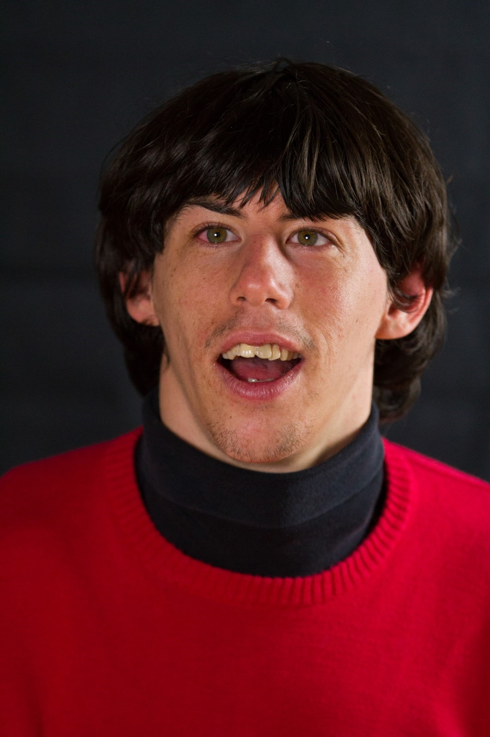
[Photo of Elijah Jenson. Elijah has shaggy dark hair, and a bright, wide smile. Elijah wears a red sweater and a black turtleneck.]

“I live in Brattleboro, Vermont next to the beautiful Whetstone Brook. My passions include music, being around water, and theater. My favorite instruments are piano and guitar. I enjoy swimming at the YMCA pool with my buddy Phil, and spending time at Spofford Lake in the summer.

I have been a troupe member of Theatre Adventure since 2004. Theater has been a wonderful place for me to learn new skills, express myself, and make lots of friends. I have been in forty-two shows over seventeen years!

It was through theater that I recently renewed my interest in exploring painting. When Theatre Adventure’s classes went online, due to the pandemic, I became the ‘assistant art teacher’ with my mom. Our summer session in 2020 was exploring Nature As Our Muse. I helped by being a role model. I love to look out the kitchen window and use the colors I see in the trees, yard, and brook. I don’t let my Cerebral Palsy get in my way when I pursue my passions. I use adapted paintbrushes, a variety of texture paint brushes and paint sticks to achieve my goals. I love to experiment with different color combinations.”

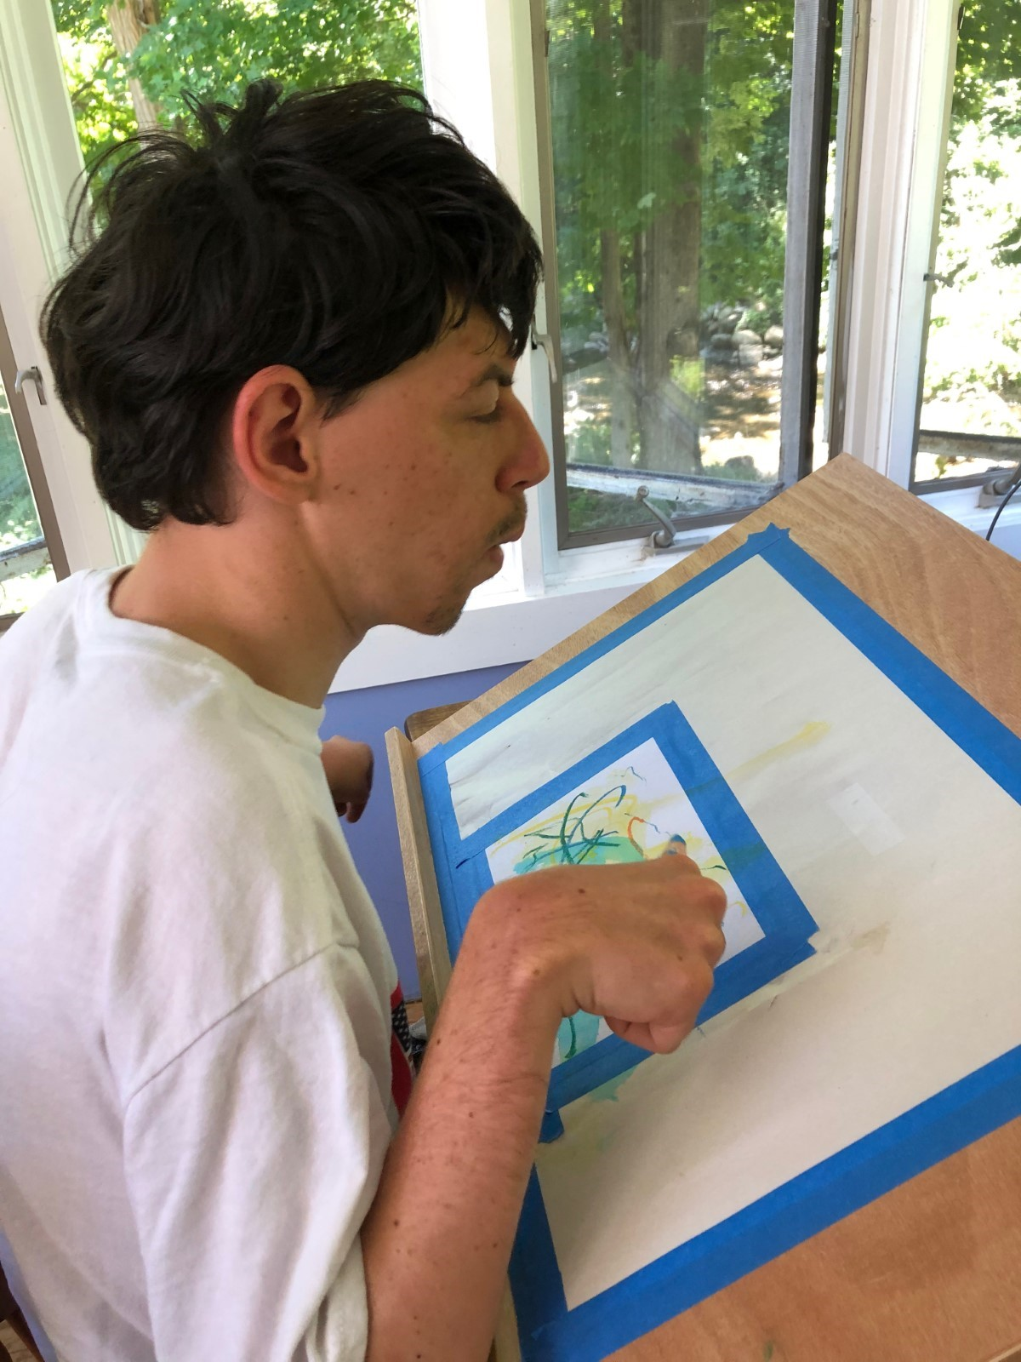Elijah Jenson at his easel with paint sticks
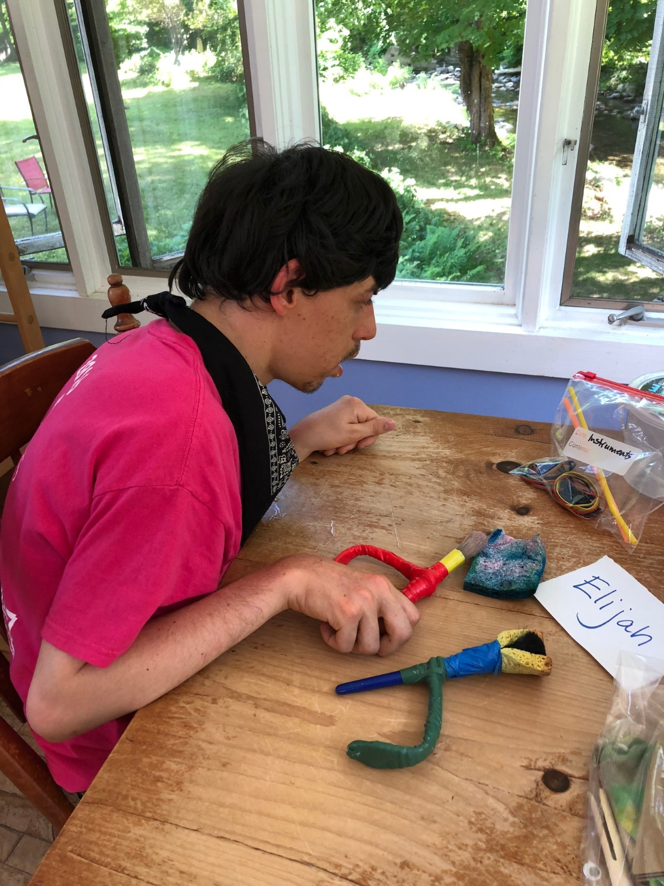 Elijah Jenson choosing adaptive paintbrush
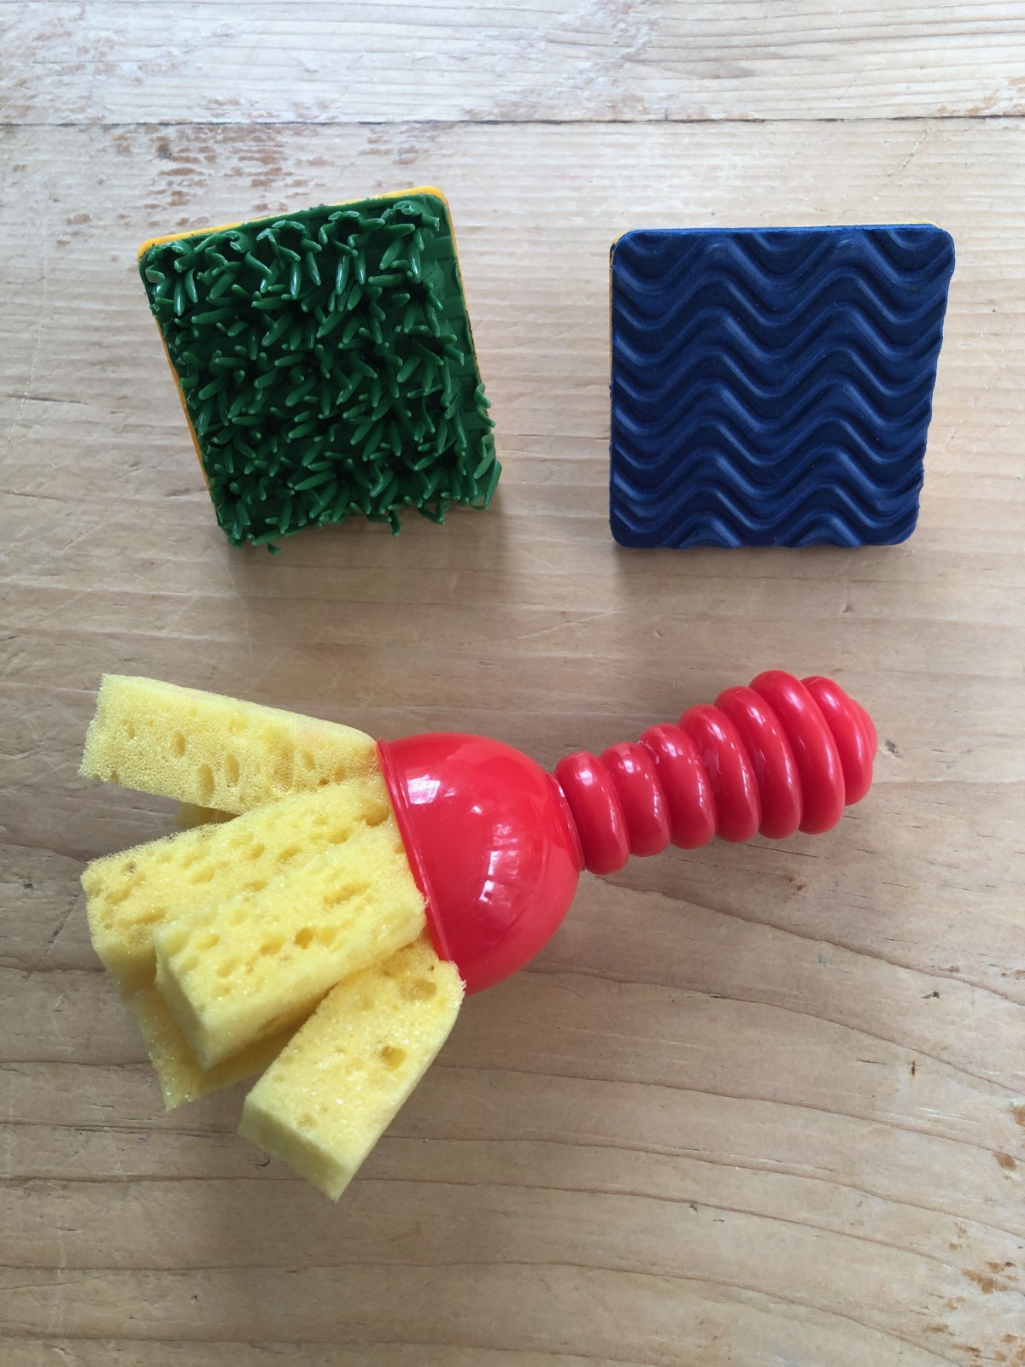Adaptive texture paintbrush & stamps

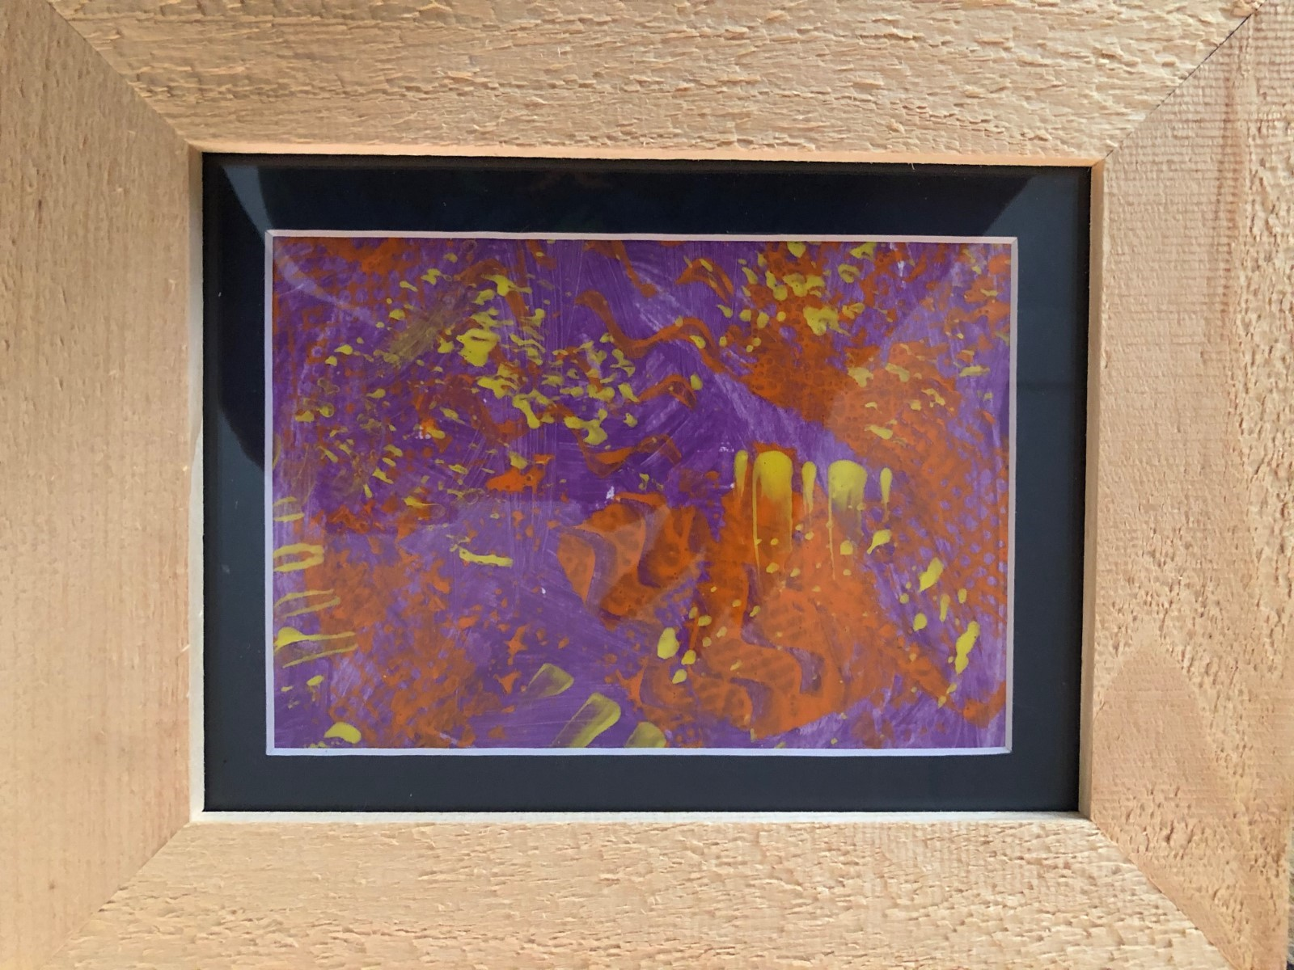

Artist Statement

My art piece is an abstract of colors in purple, orange and yellow. It is framed in a light-colored rough-cut wood frame. I thought the frame represented the Nature of Vermont because it is natural wood. The paint I used is an acrylic paint. For each color I used a texture paintbrush – Purple, I used a sponge brush to fill the paper. I then added Orange on top of the purple with a zigzag texture stamp and then I added a little Yellow with a spiky texture stamp. It was a wintery day with lots of white snow when I chose these vibrant colors to brighten my day!

Eva Seyller
Artist Biography

Eva draws inspiration from life experiences, photographs, and stories, and transforms them into abstracted images with bold colors and shapes. In her five years with Champlain Community Services, she has enrolled in every course in Adult Arts Education offered by Inclusive Arts Vermont. These courses have exposed her to the expressive potential of different media and sharpened her sense of composition. Her preferred medium remains colored pencil on paper.

Her work was included in FLOURISH, an exhibition at the Amy E. Tarrant Gallery sponsored by Inclusive Arts Vermont and the Flynn Center for the Performing Arts. She has also shown her drawings at August First Bakery & Café in Burlington and at Scout & Co. in Winooski. Her photographs have been included in group exhibitions at the Penny Cluse Café and the Fletcher Free Library.

Jill Harvey
Artist Biography

“I started art in my 20s at Howard. It is called Grace Arts. They taught me to use markers, markers and paint, and marker and watercolor for the background. A lot of my artwork has animals in it.”

Kathryn Adams
Artist Biography & Statement

“I am Abenaki.

It took me decades to learn of my true ancestry hidden in the family tree mingled with Scottish and English. As a child I loved to be outdoors, in the woods creating wildflower gardens, crawling through the meadow grasses to get closer to the deer grazing, returning fallen nestlings to the tree branch homes, loving to fish with my Dad. I sensed Abenaki heritage, finally found the genealogy documents to claim my ancestry, my hidden grandparents.

My photo collage is to honor my Grandmother, Bertha Carr, her grandmothers and grandfathers, the People of the Dawnland. The only clue she left was my remembrance of my mother telling me that Grammy would become very angry and protest when folks called her son ‘an Indian.’

My formal education: first of my family to graduate from college, University of Vermont B.S. Education followed by Masters in Education Curriculum Development, gifted to encourage students with different learning styles to find their giftedness.

More significant to me is my learning outside the classroom…in the Creator’s world where I marvel at the joy of exploring, celebrating, learning from animals and plants, and sharing with others in respect-filled communities.

Decades ago I was diagnosed with ptsd. A dozen years ago with adh. ‘d’ for ‘difference.’ I refuse to speak that I am a ‘disorder.’ Then in recent years with complex pts…. distress… even more complicated than simple ptsd…

I saw the announcement for the Masked exhibition for artists with disabilities, but I am perplexed, which category do I choose?

I choose to publicly proclaim with honor the blessings of the ancestry and culture of my hidden grandmother. She is represented in the inner circle of the collage, carrying woven baskets to sell to tourists. My grandfather is seen in the face of the young man, my grandson, with his arm around the neck of Black Hawk, a horse I bred, raised, and share as medicine horses for folks with differences. The bear rug with orange looped ribbons around the edge represents the children lost. Chief Don Stevens is chief for the Nulhegan tribe where my ancestors lived. The child looks across the pond, eyes following the ducks, with hope that we travel into the future with more compassion.

I celebrate my Abenaki family. “

Karen J. Lloyd
Artist Biography

Karen grew up inspired by the vibrant contemporary arts community of her hometown, Mystic, Connecticut. In 2004, she graduated with Departmental Honors from the University of Vermont with a BA in English and minor in Animal Studies. An art professor encouraged her to pursue art professionally, but it would be five years after graduation until she decided to take the plunge into art exhibits. Not content to be limited to one medium, she has thrown her creative energy not only into photography and acrylic painting, but has also mastered the customization and painting of realistic miniature model horses using mixed media of pastels, acrylics and colored pencils.

Her award-winning photography has been featured in numerous exhibitions in Vermont, including at the Darkroom Gallery, Champlain Valley Fair, Art + Soul, Winooski Pop-Up Gallery, Feldman’s Bagels, and University of Vermont Alumni exhibits, as well as three previous exhibits through VSA / Inclusive Arts Vermont. Karen’s art cards are offered year-round at the ArtHound Galley (Essex Junction) and Guy’s Farm & Yard (Williston location).

“Amidst the challenges of living with chronic tick illness and fibromyalgia, I have continued to explore the realm of natural aesthetics in my acrylic paintings and photography. Through whimsical beauty and dramatic contrasts, I endeavor to spark reflection upon our relationships with the animals and landscapes increasingly overlooked in a fast-paced, human-oriented society, with the hope of evoking an emotional thread to our natural surroundings. Ultimately, my pursuit is to capture and share the essence of my subject. For me, creating art that awakens a deeper emotional connection is one of the most extraordinary and rewarding challenges to achieve. Within a single piece, there is often suggestion of an allegorical dichotomy of light and dark: tempering the interweaving threads of perseverance, challenges and ‘storms,’ with themes of empathy, hope and joy.”

She resides in Winooski, Vermont with her husband and their two amazingly lovable house rabbits, River and Journey. More of Karen’s work can be explored at www.natureheartstudio.com.

Artist Statement

“The theme ‘Masked’ embodies a few different concepts for me – being covered, hidden, obscured, as well as protection and safety. Although the pandemic brought challenges, it also inspired new opportunities for my photography. In 2020, to avoid areas busy with people, my husband and I began exploring parks ‘new to us’ that were off the beaten trail enough that we could feel safe without wearing masks. One of those parks was in South Hero and resulted in my photograph ‘Promise of Tomorrow,’ captured at the top of a little hill during the ‘golden hour’ just before sunset.

I left that scene feeling inspired and remember thinking that shot made having dinner late completely worth it! There is the duality of dark shadow areas on the left contrasting with the appearance of bright light as we move our gaze from the center to the right side of the view. With a heart message written in the heavens as if watching over all below with love, the break in the clouds forms a victorious V, revealing a brilliantly blue sky, drawing focus to the illuminated tree in the center. At first glance, the tree looks alone, but in actuality it is part of a network of other trees in the distance. It can feel very isolating to have chronic illness and to be legally disabled. I sometimes grapple with feeling invisible or hidden, like there is a partial, incomplete view of myself as seen by the outside world. For me, this tree in a field represents individual perseverance while gently reminding that a supportive community (such as Inclusive Arts and fellow artists) is in the background too. As the title ‘Promise of Tomorrow’ suggests, I felt this photograph embodies faith in the future despite some ‘dark cloud’ moments. The sun-filled sky still exists, even with the presence of clouds.

Sometimes it can feel tempting to ‘mask’ our limitations and symptoms to act like the challenges don’t exist, especially as society loves the trope of the inspirational disabled person. With this photograph I hope to convey the depth of human experience – the darkness of depression to joyous moments of sunshine full of hope. I am that tree, alone in some ways yet connected, living with chronic pain, brain fog, and debilitating fatigue, and yet still reaching for my dreams in the sky. It doesn’t always feel easy or comfortable, but when we dare to lower the masks we can be more authentic, which is beautiful in its own way. A tree always embraces being a tree.”

Liam Malone
Artist Biography

Liam Malone (they/them), is a queer, non-binary, neurodivergent artist and creator, who was born and raised in southern Vermont. They are most inspired by their communities and lived experiences, and create with the intention of connection. With a background in clinical social work, Liam believes creative expression opens so many doors for healing and processing trauma both individually and collectively. In the midst of the pandemic Liam founded TheyCreate, (theycreatevt.com), an online platform for queer artists to showcase and sell their work. Liam has always found art to be a way to express their feelings and explore their identities. As a child they were always drawing (mostly rainbows). They began painting in high school, where they completed a series of self-portraits which unintentionally documented their internal struggle with the social construction of gender. Recently, Liam has enjoyed creating digital art, collage pieces, and painting for themself and others. Liam says, “for me, one of the biggest challenges of creating art is letting go of self-judgement and giving myself permission to be messy and imperfect, because when there is the added pressure to be perfect it sort of defeats the purpose of creating, which is to be my most unapologetic self, and if other people connect with what I create that’s like an added bonus.”

Artist Statement

The piece “End Paige” was created in response to the “Masked” prompt. It is a digital composition of 3 different original pieces. It tells the story of how ‘unmasking*’ both gender and neurodivergent identities helped save Liam’s life. Liam finds it ironic that during a time where masks are often mandatory, they were able to ‘unmask.’ Liam says, “around the same time I heard about this art exhibition, I also learned the term ‘neuroqueer**,’ and I was like...YES! That is it! That’s me! And this piece is really about walking into that identity and finding comfort and belonging at a time that has felt so isolating.”

*Unmasking is the process of returning to a more authentic version of oneself that had previously been confined by societal pressure to conform to social norms.

**Neuroqueer, coined by Dr. Nick Walker (she/her), is both a verb and an adjective. Dr. Nick Walker writes “A neuroqueer individual is any individual whose identity, selfhood, gender performance, and/or neurocognitive style have in some way been shaped by their engagement in practices of neuroqueering -the practice of queering (subverting, defying, disrupting, liberating oneself from) neuronormativity and heteronormativity simultaneously.” (From https://neuroqueer.com/neuroqueer-an-introduction/)

Lissa Nilsson
ARTIST BIOGRAPHY

Lissa Nilsson is originally from Michigan. She won several awards in high school art competitions and began college majoring in Art. After deciding she didn’t want to starve, Nilsson went on to earn a BA in Geography from Mount Holyoke College.

Lissa had a successful 15-year career as a cartographer. She was a Senior Geographic Analyst doing fieldwork and making digital maps for NAVTEQ before losing her job due to chronic illness. She has been mostly housebound and operating at about 30% of her former self since becoming ill with ME/CFS in 2010.

In 2015, some of Nilsson’s acrylics were selected for “M.E. Again”, an online, year-long, juried show featuring artists disabled with ME/CFS. Her paintings have also been in several Inclusive Arts Vermont exhibitions including FLOURISH, ANEW, and MASKED.

In early 2017, Nilsson and her husband discovered that their home was contaminated with toxic mold, hidden inside the walls – a revelation that turned out to be a significant factor behind their failing health. For nearly two years, they went through an excruciating saga trying to save themselves, and their house. Ultimately the remediation failed, and they were forced to leave everything behind.

In November of 2018, Nilsson and her husband, David Fontaine, hit the road with their two beloved cats. While continuing to maintain their VT residency through David’s work, they’ve been full-time RVing for the past three years. They have slowly regained some of their health in small increments and are just beginning their fourth year on the road. Throughout this unexpected trajectory, the ability to return to her roots in art has brought immense satisfaction and a sense of purpose to Lissa’s life.

Artist Statement
“inVisible illness: Behind the Smile”

This painting is mixed media on paper(s): Acrylic, colored pencil, embroidery thread, foam-board, poster board, and computer graphics. The face is raised up on foamboard to create a slight shadow and a peek behind the “mask.”

It welcomes introspection of what “invisible illness” is. People always say, “You look great!,” and are confounded by the thought that someone with chronic illness may not look sick – on a day the person is feeling well enough to be out in public.

Behind the face (a self-portrait), the brain is showcased – using written words to form the subtle textures of grey matter. The words themselves, represent all kinds of neurological problems going on, sight unseen to the casual observer.

At the base of the brain stem, nerve bundles descend and connect to a supine figure. Beneath the figure is a dashboard of warning lights, representing all the failing systems. These exemplify clusters of symptoms that are impossible to see.

Behind the face and the brain, is a grey silhouette. It represents the shadow of former self - always present as a reminder of who the artist was before becoming chronically ill. It is also grey and flat because that is what people tend to see of a person with chronic illness. It can be hard to grasp that someone with a long-term illness once had a vibrant life, full of adventure. Chronic illness somehow erases identity, and any exterior perception of former vitality.

The four colors of the background represent the four seasons. These hidden symptoms and invisible neurological dysfunctions may ebb and flow relentlessly, night and day, all year long.
Just because the person “looks fine” on the outside - doesn’t mean they aren’t sick. Invisible illness has all kinds of variables. We need to overcome the societal instinct to judge their validity based solely on appearances.

Michael Leavitt
Artist Biography

“I have been involved in artistic and creative activities since I was a child. The genre has evolved over time, and my current passion is Digital Photography.

In High School, I took art lessons at AVA Gallery, and worked for a local Public Access Station, videotaping government meetings, local sports, and creating content, including videos of the Quechee Balloon Festival.

In 2008, I was involved with the statewide art project, Art Fits Vermont. A picture of my contribution, is below. As I moved more into photography, I applied to and was accepted for the Engage Exhibit in 2012, the Flourish Exhibit in 2018, the Anew Exhibit in 2020, and now, the Masked Exhibit (2022).”

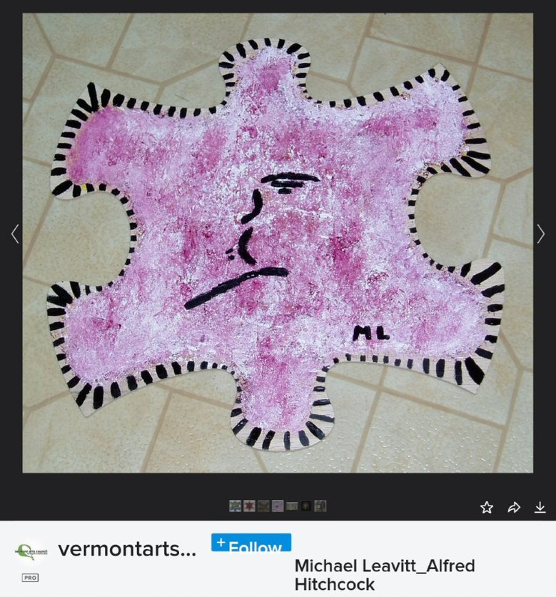

Paul Betz
Artist Biography

“My name is Paul Betz. I’m a local amateur photographer from South Burlington. I started taking photos and photography classes a few years ago and found I really enjoyed the creative process. Being in a wheelchair has its limitations, but I don’t let that keep me from doing something I feel passionate about. With a lot of patience and practice, I have developed my own ways of creating art. I have a great team of support staff that assist me in the process, and my unique method and style is what brings my photos to life. I love capturing the natural beauty of Vermont and using my personal perspective to portray simple things in special ways.”

More about Paul:
Bestbetzphotography.com
instagram: @bestbetzphotography
facebook: Paul Betz Jr

Persephone Ringgenberg
Artist Biography

Persephone Ringgenberg is currently living in Winooski, Vermont, working out of her home studio. She has a history of working with multiple art mediums, including clay, photography, writing, and acrylics.

Her most recent focus has been on acrylic paint on canvas board. She enjoys mixing various substances with her paints to explore the different textures she can create. Glitter, eye shadow, Mod Podge, and glue are just a sample of what she has included in paintings.
She tries to use her art as an avenue to share disability information and education. She strives to show that persons with different abilities, those who are not considered “neurotypical”, have much to offer in the world. She has shown her work in 5 different exhibits since 2017. This is her second expedition with Inclusive Arts.

Artist Statement

Acrylic with glitter body gel on canvas board, painted with metal putty knife.

“Panic was inspired by the pre-lock down period of Covid 19. Watching the news and seeing all the chaos that was going on around stocking up. ‘The sky is falling, the end of world is coming,’ that is what the rush for toilet paper, water, hand sanitizer, any sanitizing product felt like to me. My mom didn’t believe it was going to be a long-term event, she was wrong. Some panic found its way into me.

As I sat down to paint, this is what came out. The title came later, Panic.”

Sherridan Beyer
Artist Statement

“’Grandsons Visit’ is a watercolor painting. I sketched my youngest grandson when he was here for one of our many overnight visits. He is lying on my living room floor, which he had taken over with his toys. The yellow toolbox (right side of the painting) holds all the treasures that he keeps here and contains toys from when he was a toddler through the age this was when drawn, six. Some of the items, the wooden castle and barn, are my toys to share with all my grandkids over the years. My oldest grand is now 20. Happy meal toys, gifts, and used toys from here and there live in the box, awaiting his next visits. I am sure the hot wheel track and matchbook cars will remind many of you of your youth.

Whenever he spends the night, or weekend, we always order a cheese pizza which you will see Mario stepping in on the left side. Big blue Sully, upper right, holds my cane, representing his first walking tool, pulling himself up and the two of us sharing it to walk, usually with him leading.

When Covid 19 shut down the globe and we were unable to see each other in person, we used Skype to keep in contact. He often wanted to check on his toys, and I would bring out the toolbox, open it in front of the camera, and take each item out for his inspection so that he knew all was secure and would be here waiting for his return.

The isolation had me lonely for my family and painting the sketch to bring it to life made me feel more connected. I handled and posed each toy, deciding on its placement around him. This was a fun painting to create! I included my Christmas cactus as it represents being at a Grandmother’s home.

I collect used frames to recycle and cut my own mats, which I had plenty of time to do during lock-down.

This painting is part of my personal collection and not for sale. When he is grown, I will pass it on to him for remembering his youth and the love we have shared. I hope it sparks happy memories for those who look at it, and gives the viewer a spark of childhood magic.”

Sarah Senese
Artist Biography

Sarah was a young girl at Charlotte Elementary School when she discovered her love of markers. She remembers a drawing she did of a double rainbow which is a motif that continues in her work today. Through the years Sarah has kept up her artwork practice at home and through the Home Base Arts and Movement Classes. It was through her Home Base Humanities Class she discovered a new love, 4 years ago, that of making books. She is currently working on a book about everything in the sky which will include rainbows and clouds.

Artist Statement

During the pandemic Sarah kept drawing and through Zoom meetings with her friend, Susan from Home Base, she finished the book “Starla and the Cloud Wand,” a work she started before the pandemic. Then without missing a beat she was ready for the next, “Wish Poems.” Making this book made Sarah feel really good; it is a manifestation of her imagination in the form of words and image. Sarah is very excited to be in this art show to share her work with a wider audience.

Purchase the book at: https://app.thebookpatch.com/BookStoreResults?search=sarah%20senese&ddl=any

Tenebraria Akele
Artist Biography

Tenebraria Akele had a near death experience, as a child, after being pulled out by the undertow at Sandy Hook Beach, New Jersey. As a result, Tenebraria’s nervous system became severely deregulated. Altered states of consciousness became the norm.

As a child, Tenebraria was pulled to art as a way of expressing what he couldn’t express any other way. He often would use anything he could find to draw, color, design, or paint with. He did not have much support in life, especially during childhood. Yet, he would steal moments in hiding to create.

As an adult, Tenebraria has learned that he need not be fettered to his unregulated nervous system. Proceeds from his artwork go toward health care that is building its regulation. This is slowly opening up a new world for Tenebraria.

Artist Statement

“Beeswax Blow torch Razor blades And
Love
Are necessary for me to create encaustic artwork.
I create as a way of communicating that which cannot be communicated.
I create as a way to release the Divine energy while connecting to source.
My creations using natural organic beeswax, damar resin, and pigments are an interpretation and an expression of the natural world. Studying the encaustic medium is a journey built upon paradoxes. The laws of physics apply, yet it’s never that clear cut or easy. Beeswax combined with damar resin is the basic recipe for the medium. Pigments are added to make the paint. The paint or medium is applied while it’s in a molten state. The paint never dries it’s either in a liquid state or solid.”

