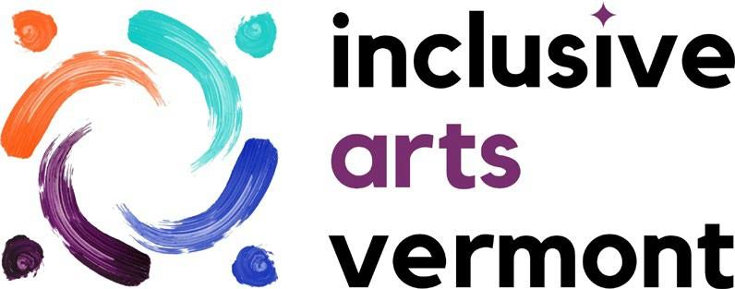

DIGITAL CONTENT MANAGER
Up to 20 hours/week
$23/hour

To apply for this position:
Send a cover letter, resume, and social media samples to:
Katie Miller, Executive Director
info@inclusiveartsvermont.org

JOB DESCRIPTION

This position is a part-time position of up to 20 hours per week, and is part of the management team of Inclusive Arts Vermont, a statewide non-profit organization dedicated to using the magic of the arts to make Vermont a more accessible and inclusive place for people with disabilities. Our arts education, cultural access, and professional development programs engage thousands annually across the state.

The primary role of the Digital Content Manager is to:
- Plan, organize, and facilitate digital programs including live artist talks and open studio events
- Develop sustaining systems for the storage of digital content and production of digital events
- Create dynamic and engaging social media content on behalf of Inclusive Arts Vermont

This is a temporary, year-long position, with funding through June 30, 2023. An extension is possible if additional funding is secured.

This position will be offered a competitive paid time off package, which you can read more about in the personnel policies on our website: https://www.inclusiveartsvermont.org/about/public-documents/

Proposed start date: July 11, 2022

BASIC FUNCTION
The responsibilities of this position are centered in digital event management, communications, and marketing.
LOCATION
This is a remote role. The ability to attend occasional in-person staff meetings is preferred, but 100% remote candidates will be considered.

DUTIES & RESPONSIBILITIES

Social Media & Web Communications: 40%
- Research and prepare content for social media
- Schedule advance social media posts
- Create and launch new platforms for the organization, including TikTok, Pinterest, and Linked In
- Create and maintain the monthly social media report for the Board of Directors
- Create and publish dynamic, engaging, and interactive content across all social media platforms

Digital Events: 50%
- Ensure digital programming meets accessibility standards and guidelines
- Manage accessibility elements of digital content, including, but not limited to ASL, captioning, verbal description, and creating transcripts
- Supervise and produce all digital events for the organization, including the monthly artist talk series
- Develop and implement new, public digital events for the organization
- Attend digital events to provide tech support to staff

Other: 10%
- Research, and present findings, on best digital practices, technologies, and platforms for digital content for the organizations
- Provide technological support and guidance to members of the management team and teaching artists on how to best deliver digital content to students via ZOOM or other streaming platforms
- Organize and edit past digital content for reuse and repurposing (I.e. taking snippets from an hour-long artist talk and creating soundbites for social media)
- Work with the Development & Communications Director to create an annual communications plan
- Create and document a new system for storing and archiving digital content including photos, video, and podcast episodes

CULTURE OF INCLUSION
At Inclusive Arts Vermont, we believe that we all bring different strengths to the management team and celebrate them. Additionally, all employees of the organization are expected to participate in and support a culture of inclusion, through the support of other staff members as needs arise. Examples of this include: photocopier assistance, mailing stuffing, lifting, zoom tech, etc.

SUPERVISION EXERCISED
This position does not supervise any employees or interns.

SUPERVISION RECEIVED
General direction and supervision is received from the Development & Communications Director.

QUALIFICATIONS
- Passion for the mission of Inclusive Arts Vermont and an interest in diversity awareness and disability inclusion
- Strong writing skills
- Strong time management skills, ability to prioritize and meet deadlines
- Proficiency in Adobe Creative Suite or similar design software
- Advanced knowledge of major social media platforms including Facebook, Twitter, Instagram, and TikTok
- Experience with collecting an analyzing performance and engagement data for social media
- Experience with developing engaging content for a variety of social media platforms including facebook, twitter, and instagram
- Good level of accuracy in all aspects of work
- Good verbal and interpersonal communication skills
- Excellent problem-solving skills
- Able to maintain confidentiality of sensitive data and information
- Able to pass all agency background checks
- Physical ability to perform all job functions

ACCESSIBILITY:
To receive this application in a different format, or to make an accommodation request regarding the application process specifically, please contact Katie Miller: katie@inclusiveartsvermont.org 802-404-1597

Equipment Used:
Office Equipment: Phone, computer, camera, lights

Mental Demands/Physical Demands/ Environmental Demands:
- Work is sedentary for long periods while spending a lot of time keyboarding and looking at a computer screen
- Work with frequent interruptions; regulate emotions under stress when meeting deadlines
- Person must be able to prioritize multiple tasks and work independently

Employment is conditioned upon:
- verification of the individual’s identity by examining the individual’s government-issued photo identification card, such as a driver’s license
- completion of a Vermont Criminal Information Center record check
- review of the National Sex Offender Public Registry
- an FBI fingerprint check
Any individual who does not consent to the above screenings, or who makes a false statement in connection with the above screenings, will not be eligible for employment or placement in Inclusive Arts Vermont programs.

Appropriate staff will review the findings of the background check information, as they become available. Confirmation of an offer of employment will be contingent upon the completion of the above background checks, and a finding that the information in these records was accurate, complete and non-disqualifying. Inclusive Arts Vermont will follow all Vermont Criminal Information Center policies related to the employers’ maintenance of criminal record check information.

Unfavorable background check information is not an automatic bar to employment or placement at INCLUSIVE ARTS Vermont. Unfavorable information obtained from these background checks is reviewed by the appropriate staff, with consideration given to:
- the date and nature of the conviction,
- age of the applicant when the offense was committed,
- whether there is any evidence of a criminal pattern, and
- the nature of the employee’s or volunteer’s work roles at Inclusive Arts Vermont.

An employee, volunteer or candidate may dispute the factual accuracy of the result of a background check with the appropriate agency. Upon request, Inclusive Arts Vermont will provide the individual with appropriate contact information to dispute a finding. In this case, a final enrollment decision will be based on the official resolution of the dispute.

Any Inclusive Arts Vermont offer of employment or volunteer placement will be considered conditional pending hiring and supervisory staff’s review of the applicant’s background check information, as obtained from the Vermont Criminal Information Center, the National Sex Offender Public Registry, and an FBI fingerprint check. Inclusive Arts Vermont reserves the right to terminate an employee or volunteer immediately if information discovered through a background check after the applicant commences their employment or volunteer placement reveals a previously unknown criminal record, the content of which is determined by Inclusive Arts Vermont hiring and supervisory staff to disqualify them to work for Inclusive Arts Vermont in that capacity.

By State law, Inclusive Arts Vermont cannot disclose the information in the background check to anyone other than the applicant.

