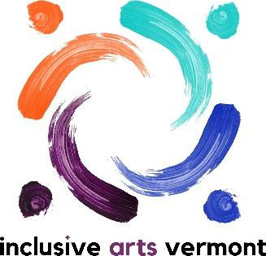

Board Member Application

Name __________________________________________ Date of Application_____________

Address_____________________________________________________________________

Phone _____________________________________

Email _____________________________________

What draws you to our board? _____________________________________________________________________________

_____________________________________________________________________________

What experience and skills will you contribute to our organization?

_____________________________________________________________________________

Educational Background (not required for board participation)

___________________________________________________________________________

___________________________________________________________________________

Current Occupation or Employment (not required for board participation)

____________________________________________________________________________

____________________________________________________________________________

Please check any areas of expertise that apply to you:

□ Arts
□ Disability Awareness
□ Education
□ Development/Fundraising
□ Nonprofit Finance
□ Management
□ Government/Legal
□ Marketing Communications/Media
□ Music
□ Dance/Movement/Physical Education
□ Performance/Public Speaking
□ Graphic Design
□ Technology

Inclusive Arts Vermont conducts criminal background checks of employees and volunteers. A separate form will be given after the completion of an interview.

Please list 2 associates whom we could reach by phone as references:

- ______________________________________________________________________

- ______________________________________________________________________

Please attach a resume and a statement of interest related to work for Inclusive Arts Vermont. These can be done as a written document or in an alternative method.

Alternative methods include, but are not limited to: audio or video recording.

Please email completed form, resume and statement of interest to: board@inclusiveartsvermont.org

_________

For assistance with this application, please contact Sarah Brown:
sarah@inclusiveartsvermont.org
802-505-6395

