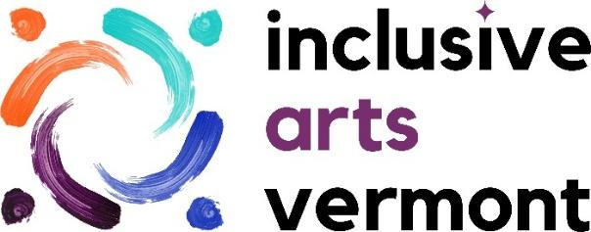

**ARTIST APPLICATION**

*CYCLES*: An exhibition of work by Vermont artists with disabilities

To receive this application in an alternate format such as large print, braille or PDF, or for assistance completing it, contact Heidi Swevens with Inclusive Arts Vermont at 802-556-3668 or exhibitions@inclusiveartsvermont.org

**CONTACT INFORMATION**

**Name:**

**Pronouns:**

**Mailing Address:**

**Phone Number:**

**Email:**

**Website (optional):**

**Are you 18 or older:**

**Contact Information for Support Person Assisting with this Application (if applicable)**

**Name:**

**Pronouns:**

**Mailing Address:**

**Phone Number:**

**Email:**

**Yes/No: Please include both artist and support person on exhibit-related communications.**

**ARTIST PROFILE**

**Artistic Discipline or Medium:** (ceramic, collage, painting, photography, fiber arts, etc.)

**Optional - Artist Bio:** (Potential Questions: When did you start creating artwork? What motivated you to begin creating artwork? How has disability shaped your art practice?)

**Artist statement:** (how does your artwork relate to the theme *CYCLES*?)

**Is there anything else you would like to tell us about yourself or your artwork?**

**Optional - Cycles is an exhibition of new and established artists. If you’ve exhibited before and would like to share, let us know your exhibition experience.**

**REQUIRED SAMPLES OF ARTWORK**

***If you need technical help with this part of the application please contact*** [***exhibitions@inclusiveartsvermont.org***](mailto:exhibitions@inclusiveartsvermont.org)***. We are more than happy to assist.***

Please submit up to five (5) digital images in JPG format via email with this application or on a USB with a print copy. Digital images should be saved in JPG format at a high quality (300dpi) with a file size of no more than 5 MB each.

Image specifications:

-JPG files should be titled using the applicant name and image number. Example: JaneSmith01

-Image numbers should correspond to the numbers and titles on your image list.

**Image List:**

Please list your submitted images below, following this format:

Artist Name, Title of Work, Year Completed, Media, Size

Example:

01 - Jane Smith, Portrait of My Dog, 2020, Oil on Canvas, 24"x36"

02 - Jane Smith, Portrait of My Cat, 2021, Oil on Canvas, 24"x36"

1.)

2.)

3.)

4.)

5.)

Send Completed Applications by September 22, 2023 to:

E-mail: exhibitions@inclusiveartsvermont.org

Postal Mail:

Inclusive Arts Vermont

ATTN: Exhibitions

P.O. Box 236

Essex Junction, VT 05452