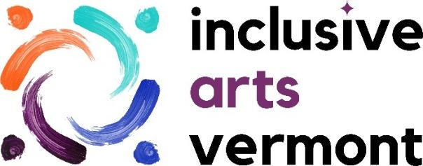

**CYCLES FAQ**

We are excited to be receiving many responses to our call to artists for *CYCLES*. We have created this frequently asked question document to help share more details. Please contact us if you have additional questions or inspirations!

***What are the deadlines?***

**Timeline:**

Call to Artist Announced August 15, 2023

Deadline for Submissions October 2, 2023

Submission Review by Jury Team October 2023

Artists Notification November 2023

Artwork Due December 2023

Statewide Tour Begins February 2024

***How do I need to prepare my images?***

Completed application form, image samples, and image list must be submitted online or postmarked by October 2, 2023.

Please submit up to five (5) digital images in JPG format:

Digital images should be saved in JPG format at a high quality (300dpi) with a file size of no more than 5 MB each. JPG files should be titled using the applicant name and image number. Example: JaneSmith01 -Image numbers should correspond to the numbers and titles on your image list.

***If you need technical help with this part of the application please contact exhibitions@inclusiveartsvermont.org. We are more than happy to assist.***

***What does IAV provide for exhibiting artists?***

Inclusive Arts Vermont provides:

* + show installation, including art transport, at several venues throughout the state
  + increased awareness and promotion for the artist and their art on our website, in newsletters, and on our social media platforms
  + focused promotion of artists website, online shops, and connecting our audiences to more of your artwork
  + Potential for public facing artist talks and events (depending on grants)
  + support in framing artwork (if needed)
  + free artist networking events with other exhibiting artists facilitated by IAV staff
  + professional development support in writing artist bios, artist statements, and photographing of artwork (if desired)

**Accessibility:**

All tour venues will be physically accessible. As part of these exhibitions, we offer a full range of accessibility services including print materials in braille and large print, an audio tour, verbal descriptions of every work in the show, tactile elements, sensory kits, and ASL and captioning at events upon request.

***Can I sell my work?***

Yes, The artists are compensated directly if the work sells, and Inclusive Arts Vermont does not take a commission (though some venues do). That has been 20-30%.

**If you prefer to talk to a human, we are here!**

**If there are any questions not covered here please reach out. We are more than happy to work through any questions or inspirations. To receive this information in an alternative format contact** [exhibitions@inclusiveartsvermont.org](mailto:exhibitions@inclusiveartsvermont.org) **or call 802-556-3668.**