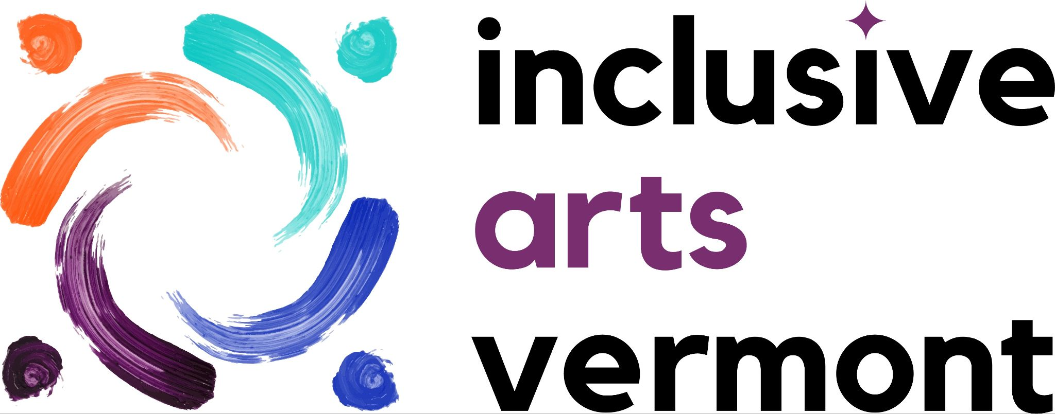

FOR IMMEDIATE RELEASE

Contact:
Megan Bent
Director of Communications and Digital Access
Inclusive Arts Vermont
802-556-3668
megan@inclusiveartsvermont.org

Inclusive Arts Vermont’s 5th Biennial Exhibition, CYCLES, Showcases Artwork from Vermonters with Disabilities

ESSEX JUNCTION, VT — Building on the success of four prior exhibitions and a robust network of community partnerships, Inclusive Arts Vermont will be hosting our 5th biennial exhibition, CYCLES, throughout 2024. CYCLES will highlight artwork by 25 Vermont artists with disabilities as they explore the title theme.

The exhibition will tour the state throughout 2024 beginning with an opening reception at the University of Vermont’s Dudley H. Davis Center (590 Main St, Burlington) on Wednesday, February 21 from 4pm to 7pm, co-hosted in partnership with the University of Vermont School of the Arts, Center on Disability and Community Inclusion, and the Davis Center and Department of Student Life at UVM. Subsequent stops on the tour will include the Vermont Statehouse in Montpelier, All Souls Unitarian Universalist in Brattleboro, St. Johnsbury Athenaeum in St. Johnsbury, and concluding with a return to Burlington at UVM’s Center on Disability and Community Inclusion in late 2024. In addition to an opening reception and public gallery hours at each venue, the tour will also include digital artist talks and hands-on family artmaking events throughout the year.

Heidi Swevens, Director of Community Partnerships and Exhibitions, reflects: “‘We have come to understand IAV’s exhibitions as ‘more than art on the wall.’ Yes, the art is exciting and engaging. What I find equally compelling is the artists’ stories. The creative processes. Partners’ enthusiasm and support. People with and without disabilities creating community with art and access at the center.”

Disability representation matters. According to the CDC, nearly 25% of adults in Vermont have a disability. Beyond individuals, environments can be disabling too. The social model of disability points out external barriers that impact access and inclusion. Inclusive Arts Vermont has invited artists and partners to collaborate on accessibility features like verbal description, alternative print formats, and tactile elements to eliminate some known barriers. These features are part of the show itself. Through creativity and connection, we hope CYCLES will bring diverse perspectives of disability experience to increase community inclusion.

CYCLES artist Leah Schulz shares this perspective in her artist bio: “For the last five years, I have been cycling, in and out, up and down, riding the waves of chronic illness… I have been socially, financially, and systematically removed from society… The only thing that tethered me to society is art. I leaned into a different side of my brain that I had never allowed myself to explore before and found I loved crochet, block printing, and painting. This is my first piece to be included in an art show. I am grateful to Inclusive Arts Vermont for giving me a way to exist in these places again.”

Sarah Brown, Executive Director, stressed that “visitors of the CYCLES exhibition will have an opportunity to experience art and access in a different, more intentionally inclusive way that may have never been available to them. Participants will be encouraged to interact with the exhibit access features, including sensory and tactile elements, expanding the world of the art and their experience with each piece.”

As part of the February 21 exhibition opening, Inclusive Arts Vermont will offer accessibility services including a physically accessible venue, American Sign Language interpretation, assisted listening, Braille, large print, an audio tour, access for people with blindness and low vision, tactile elements, and a quiet space. Those with additional access requests are encouraged to contact Heidi Swevens at exhibitions@inclusiveartsvermont.org or (802) 556-3668.

Learn more about the exhibition by visiting: https://www.inclusiveartsvermont.org/exhibitions/cycles/
Sign up to receive our newsletter and like and follow us on Facebook, Instagram and LinkedIn to receive the latest updates on the exhibition as it travels the state throughout 2024.

CYCLES is made possible through funding provided by Vermont Humanities, the Vermont Community Foundation, and a group of generous individuals.
_____________________________________________________________________________________
About Inclusive Arts Vermont: Originally named Very Special Arts of Vermont, Inclusive Arts Vermont was founded in 1986 as a member of the national VSA network, a program of the John F. Kennedy Center for the Performing Arts. Inclusive Arts Vermont makes Vermont more accessible for people with disabilities both through and in the arts through education, training, and exhibition programs. Our mission is to use the magic of the arts to engage the capabilities and enhance the confidence of children and adults with disabilities. We do this through education, exhibition, and capacity building programs for teachers, students, artists, and organizations. Our vision is that through our work in the arts, Vermonters of all abilities will have equal opportunities to engage in their communities and express themselves. We envision a Vermont where any person with a disability can enter any arts organization or learning environment and fully participate to the extent that they desire.

